
DEPARTMENT OF ROBOTICS & ARTIFICIAL INTELLIGENCE
Total Marks: 7.5

Obtained Marks:

Artificial Neural Network
LAB

Project Report

Satellite Land-Use Classification Using an Artificial Neural Network with Feature Engineering

Last Date of Submission: 20th October, 2026

Submitted To: Muhammad Hasaan Mujtaba
Submitted By:

Name | Registration Number
Daniyal Khaliq | 23108295

DEPARTMENT OF ROBOTICS & ARTIFICIAL INTELLIGENCE

Table of Contents
1. Introduction 3
2. Problem Statement and Objectives 3
3. Dataset Description 3
4. Methodology 4
4.1 Preprocessing 4
4.2 Train/Test Split 4
4.3 Baseline ANN (Raw Pixels) 4
4.4 Feature Engineering 5
4.5 Feature Scaling 5
4.6 Feature-Engineered ANN 5
4.7 Tools and Libraries 5
5. Results 6
5.1 Overall Accuracy 6
5.2 Learning Curves 6
5.3 Confusion Matrices 6
5.4 Per-Class Performance 7
6. Discussion 8
7. Limitations and Future Work 8
8. Conclusion 8

1. Introduction
Satellite images are widely used to study how land is being used, for example farmland, forests, water bodies and built-up areas. Labeling such images by hand is slow, so automatic classification is useful for urban planning, agricultural monitoring and environmental protection.
This project uses an Artificial Neural Network (ANN) to classify small satellite image patches into land-use categories. The data comes from the EuroSAT dataset. The project follows the workflow taught in the course: loading and preprocessing the data, splitting it into training and testing sets, engineering features, training an ANN and evaluating it on unseen data.
Two models are built and compared. The first is a baseline ANN trained directly on raw pixel values. The second is an ANN trained on a small set of engineered features describing color, brightness and texture. The comparison shows how much feature engineering improves the result.

2. Problem Statement and Objectives
Problem statement: given a 64 x 64 RGB satellite image patch, predict which of five land-use classes it belongs to (AnnualCrop, Forest, Residential, River or SeaLake).
The objectives of the project are:
- To prepare an image dataset for neural network training (loading, resizing and normalizing).
- To split the data into training and testing sets in a way that keeps class proportions equal.
- To build a baseline ANN on raw pixels and record its accuracy.
- To design image features (color statistics, color histograms and edge features) and train a second ANN on them.
- To evaluate and compare both models using accuracy, confusion matrices, precision, recall and F1-score.

3. Dataset Description
EuroSAT is a land-use and land-cover dataset built from Sentinel-2 satellite images. The RGB version contains 27,000 labeled image patches of 64 x 64 pixels in 10 classes. Because of the limited time and computing resources available, this project uses five visually distinct classes, giving 14,500 images in total.
Class | Total Images | Training | Testing | Description
AnnualCrop | 3,000 | 2,400 | 600 | Farmland
Forest | 3,000 | 2,400 | 600 | Wooded areas
Residential | 3,000 | 2,400 | 600 | Housing areas
River | 2,500 | 2,000 | 500 | River channels
SeaLake | 3,000 | 2,400 | 600 | Open water
Total | 14,500 | 11,600 | 2,900
Table 1: Classes and number of images used
Figure 1 shows three sample images from each class. Forest and SeaLake are both dark, which makes them easy to confuse using raw color values, while Residential images contain many small edges from roads and buildings.
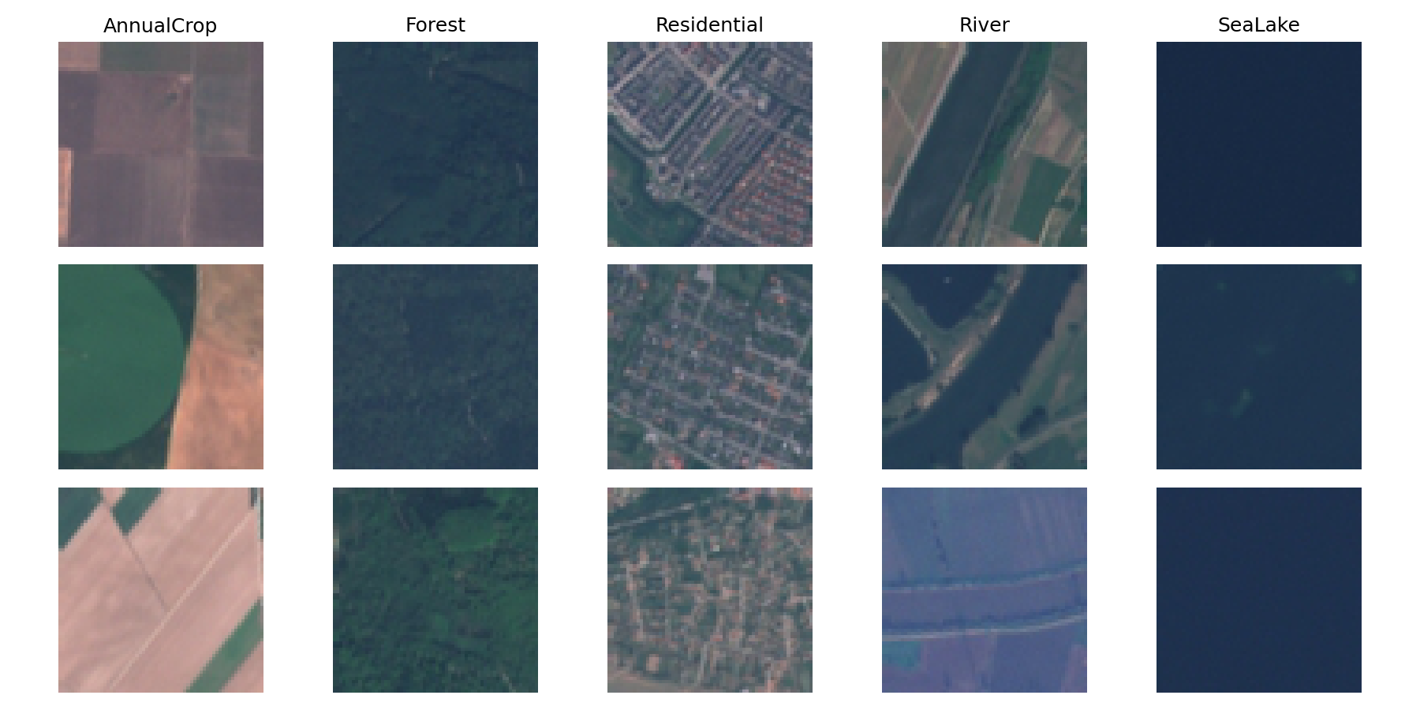
Figure 1: Sample images from each of the five classes

4. Methodology

4.1 Preprocessing
Every image was opened with Pillow, converted to RGB and kept at 64 x 64 pixels. Images were stored as NumPy arrays and each class was given a numeric label from 0 to 4. Pixel values were divided by 255 so that they lie between 0 and 1, which helps neural networks train more stably.

4.2 Train/Test Split
The data was split into 80% training (11,600 images) and 20% testing (2,900 images) using scikit-learn's train_test_split with a fixed random seed (random_state = 42) and stratification, so that every class has the same proportion in both sets. The test set was not used during training or tuning and was used only for the final evaluation. During training, 20% of the training data was also set aside as a validation set (validation_split = 0.2) to monitor progress after each epoch.

4.3 Baseline ANN (Raw Pixels)
For the baseline, each image was flattened into a vector of 12,288 values (64 x 64 x 3). The network has two hidden layers with ReLU activation and a softmax output layer with one neuron per class. It was trained with the Adam optimizer and sparse categorical cross-entropy loss for 20 epochs with a batch size of 64.
Layer | Neurons | Activation | Parameters
Input (flattened image) | 12,288 | - | -
Dense 1 | 128 | ReLU | 1,572,992
Dense 2 | 64 | ReLU | 8,256
Output | 5 | Softmax | 325
Total |  |  | 1,581,573
Table 2: Architecture of the baseline ANN

4.4 Feature Engineering
Instead of giving the network every pixel, each image was described by 39 numbers that summarize its color, brightness and texture. These features were chosen after studying the mistakes of the baseline model, which confused Residential with AnnualCrop and SeaLake with Forest

Feature Group | Count | What It Captures
RGB mean and standard deviation | 6 | Overall color of the image and how much it varies in each channel
HSV mean and standard deviation | 6 | Hue, color intensity (saturation) and brightness, closer to how people see color
Color histograms (8 bins x 3 channels) | 24 | How pixels are spread from dark to bright in each color channel
Edge features (Sobel filter) | 3 | Mean edge strength, its variation and the fraction of strong-edge pixels, which describe texture
Total | 39
Table 3: Engineered features

4.5 Feature Scaling
The 39 features have very different ranges, so they were standardized with scikit-learn's StandardScaler (mean 0, standard deviation 1). The scaler was fitted on the training features only and then applied to the test features. This avoids data leakage, which would happen if information from the test set influenced the scaling.

4.6 Feature-Engineered ANN
The second network takes the 39 scaled features as input. It uses the same type of layers, optimizer and loss function as the baseline, so the only difference between the two experiments is the input. It was trained for 40 epochs with a batch size of 64.
Layer | Neurons | Activation | Parameters
Input (engineered features) | 39 | - | -
Dense 1 | 64 | ReLU | 2,560
Dense 2 | 32 | ReLU | 2,080
Output | 5 | Softmax | 165
Total |  |  | 4,805
Table 4: Architecture of the feature-engineered ANN

4.7 Tools and Libraries
The project was written in Python 3.13 using Jupyter Notebook, with NumPy 2.3.5, Pillow 12.0.0, scikit-image 0.25.2, scikit-learn 1.7.2, TensorFlow/Keras 2.21.0 and Matplotlib 3.10.6.

5. Results

5.1 Overall Accuracy
Both models were evaluated on the same 2,900 test images that were never used in training.
Model | Input Size | Parameters | Test Accuracy
Baseline ANN (raw pixels) | 12,288 | 1,581,573 | 74.76%
Feature-engineered ANN | 39 | 4,805 | 96.31%
Improvement |  |  | +21.55 points
Table 5: Test accuracy of the two models
The feature-engineered model is far more accurate while using about 330 times fewer parameters than the baseline.

5.2 Learning Curves
Figures 2 and 3 show accuracy and loss at each epoch. The baseline improves slowly and its validation curve is unstable. The feature-engineered model reaches about 95% accuracy within the first ten epochs, and its training and validation curves stay close together, so there is no sign of serious overfitting.
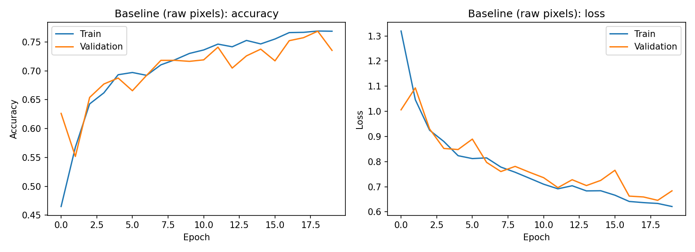
Figure 2: Learning curves of the baseline ANN
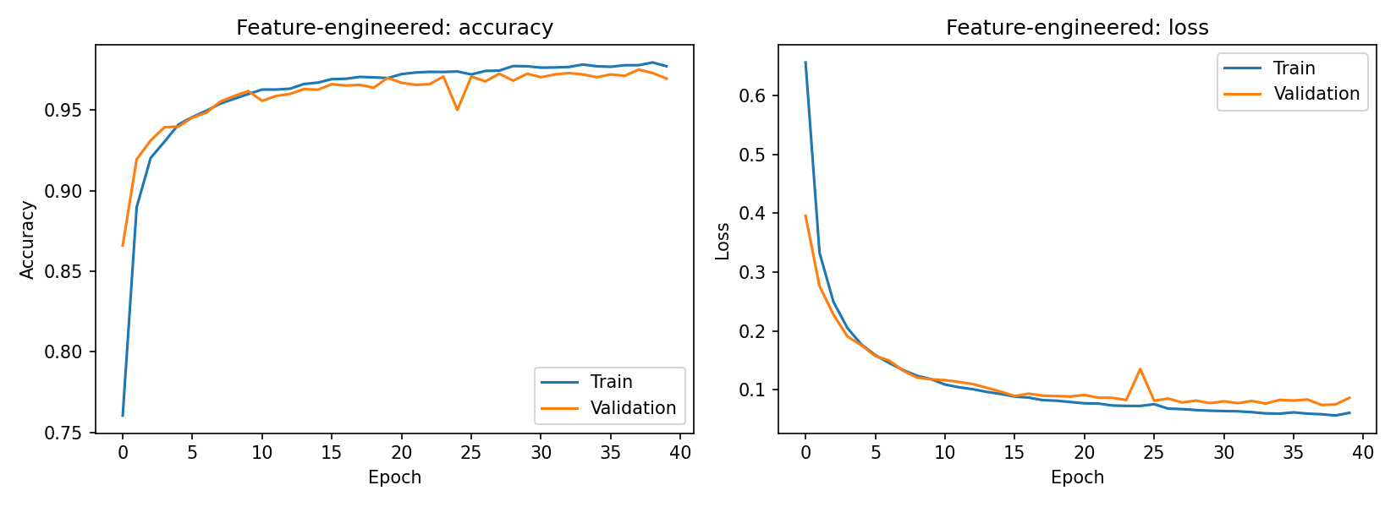
Figure 3: Learning curves of the feature-engineered ANN

5.3 Confusion Matrices
In a confusion matrix, rows are the true classes and columns are the predicted classes, so the diagonal shows correct predictions. The baseline made large mistakes: 132 Residential images were predicted as AnnualCrop, 119 SeaLake images as Forest, and 73 River images as AnnualCrop. With engineered features these mistakes fell to 0, 0 and 36 respectively.
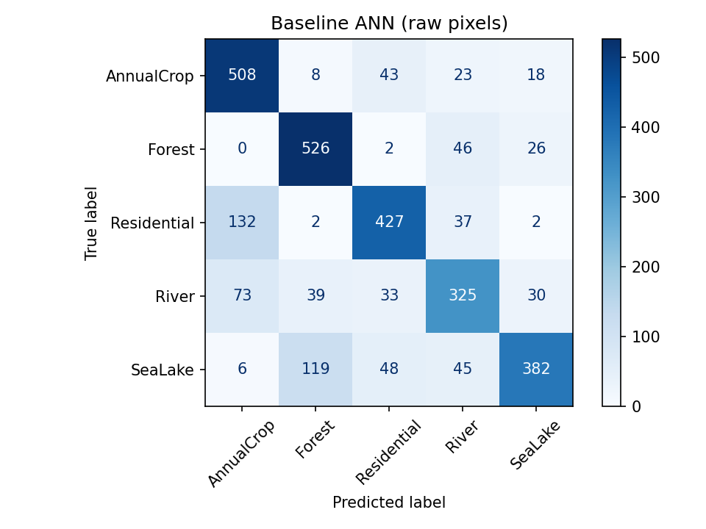  Figure 4: Confusion matrix of the baseline ANN | 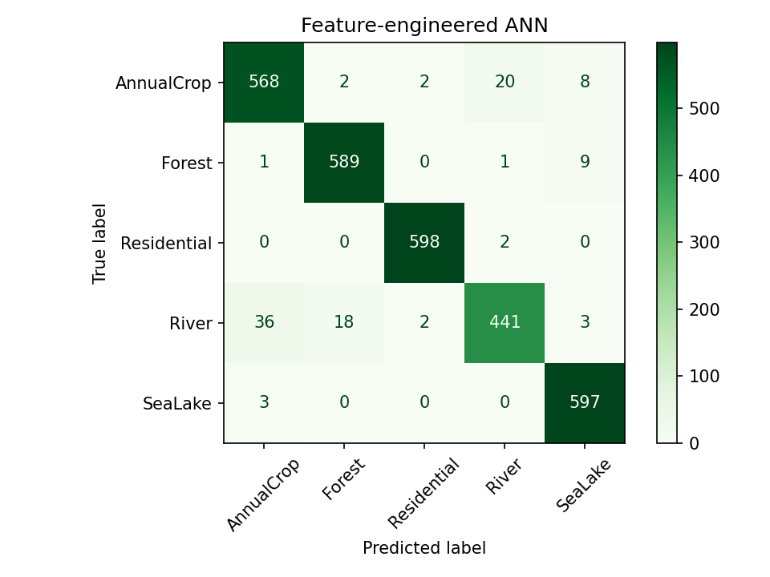  Figure 5: Confusion matrix of the feature-engineered ANN

5.4 Per-Class Performance
Class | Base Prec. | Base Recall | Base F1 | FE Prec. | FE Recall | FE F1
AnnualCrop | 0.71 | 0.85 | 0.77 | 0.93 | 0.95 | 0.94
Forest | 0.76 | 0.88 | 0.81 | 0.97 | 0.98 | 0.97
Residential | 0.77 | 0.71 | 0.74 | 0.99 | 1.00 | 1.00
River | 0.68 | 0.65 | 0.67 | 0.95 | 0.88 | 0.91
SeaLake | 0.83 | 0.64 | 0.72 | 0.97 | 0.99 | 0.98
Table 6: Precision, recall and F1-score per class (Base = baseline ANN, FE = feature-engineered ANN)
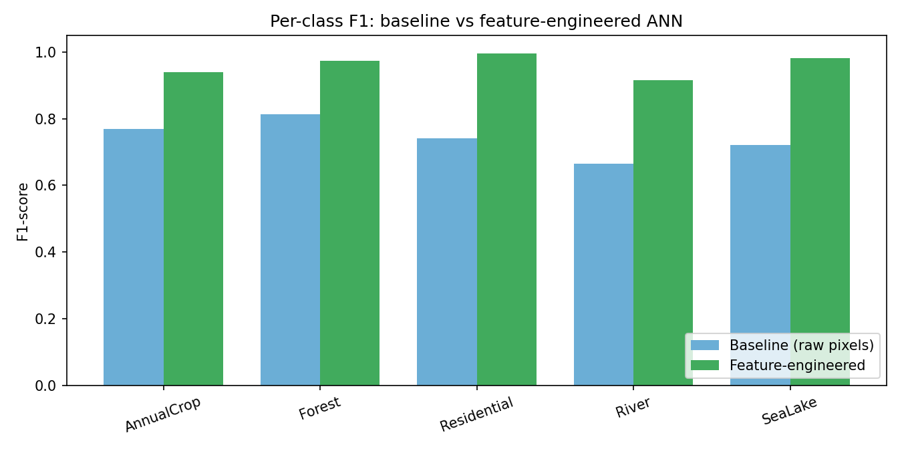
Figure 6: Per-class F1-score of the baseline and feature-engineered ANN

6. Discussion
Every class improved when engineered features were used. The largest gains were for Residential, whose F1-score rose from 0.74 to 1.00, and SeaLake, which rose from 0.72 to 0.98.
Raw pixels only tell the network the color at each position. They give no direct information about texture or overall color balance, and the network has to learn these from 11,600 examples while handling 12,288 inputs. The engineered features supply this information directly. Edge features separate Residential areas, which have

many roads and buildings, from smooth farmland. Color and brightness statistics separate the blue-toned SeaLake images from the green-toned Forest images.
River is still the weakest class (F1 = 0.91, recall = 0.88). Rivers differ a lot in color and shape and are often surrounded by fields and trees, so their color and texture statistics overlap with AnnualCrop and Forest.

7. Limitations and Future Work
- Only five of the ten EuroSAT classes were used, so the task is easier than the full dataset.
- The results come from one train/test split with one random seed. Repeating the experiment with several seeds or cross-validation would give a more reliable estimate.
- The features were designed by hand. Texture features such as LBP or GLCM could help the River class further.
- A Convolutional Neural Network (CNN) could learn features automatically and may reach higher accuracy, especially on all ten classes.

8. Conclusion
This project built an Artificial Neural Network to classify satellite images into five land-use classes. A baseline ANN trained on raw pixels reached 74.76% test accuracy. After engineering 39 color, brightness and edge features, scaling them and training a much smaller ANN, test accuracy rose to 96.31%, an improvement of 21.55 percentage points.
The project shows that good feature engineering can matter more than network size, and that a proper stratified train/test split, with scaling fitted only on training data, gives results that can be trusted on unseen images.

